**Name: احمد سعيد عابد عبد المؤمن**

**Course code: ECE001**

**Date: 2019_2020**

**BN: 64**

**Title: Database Systems**

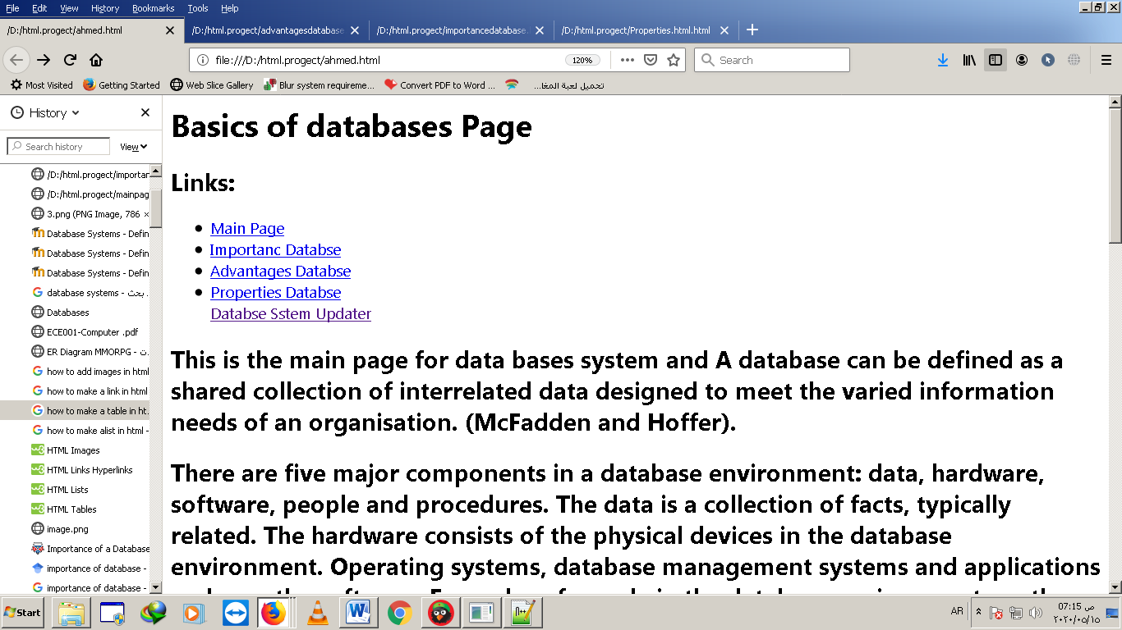Sectionscreenshots:

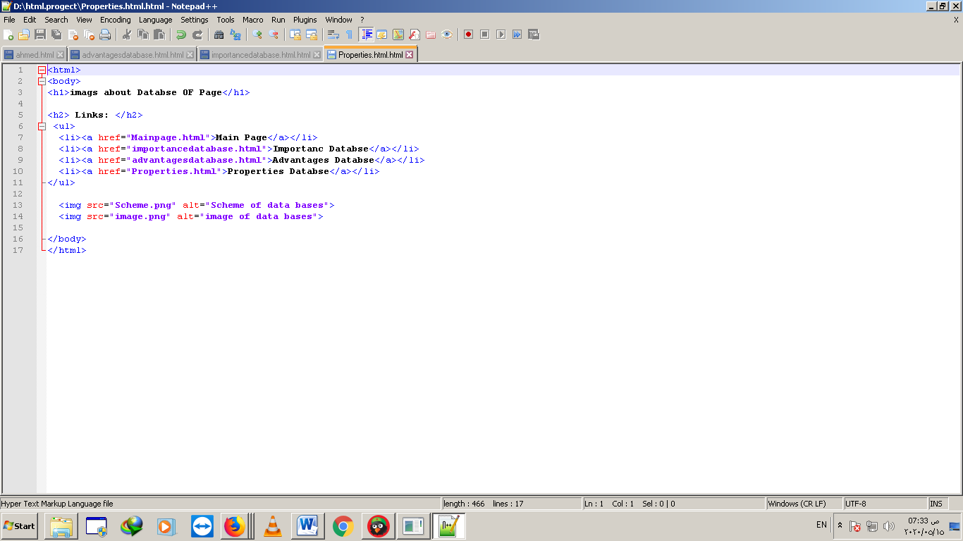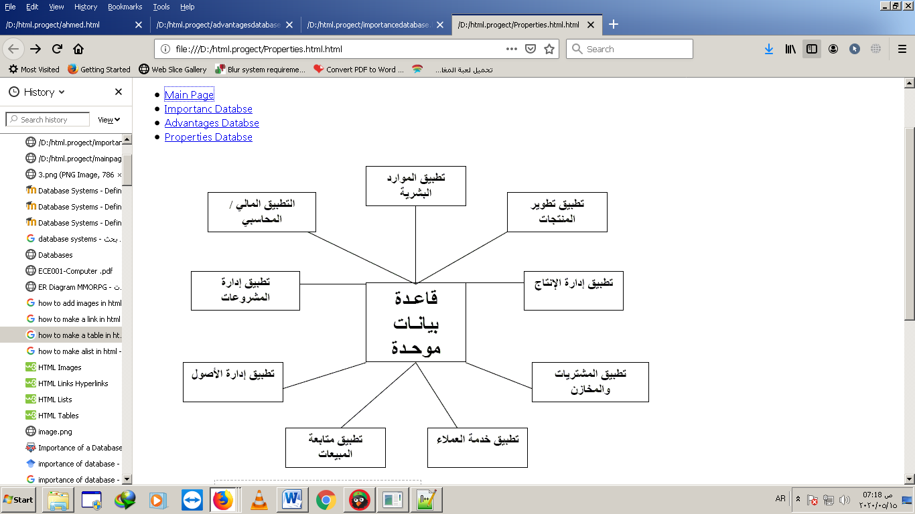

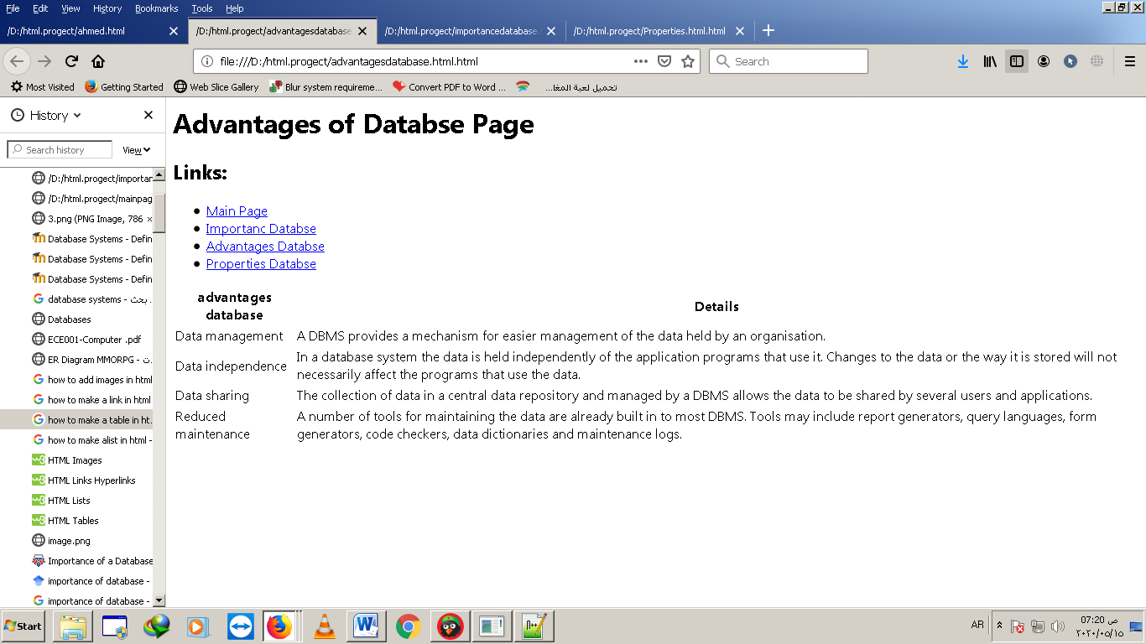

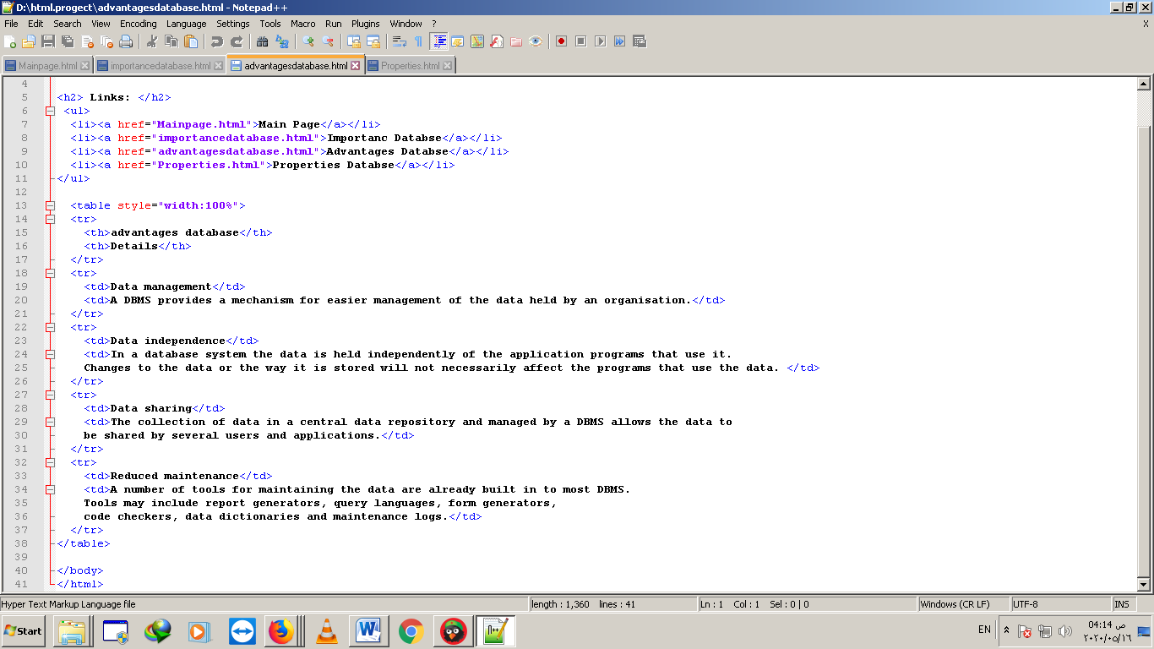

**Application brief:**

# The data base is:

In a simple way devoid of the concepts of technology, a database is a place to keep certain data continuously in order to refer to it when needed, so the phone book we used in the past is a database. The vast amount of paper accounting invoices stored in the tanks of the financial divisions of companies in the past is also a database .Measure many real and concrete examples.

We conclude from this simple definition that there is an important characteristic of the database, which is "continuity" or "permanence" in preserving data.

On the technical and programmatic side, the Database is a repository in which data is kept inside a computer or server, and this repository has the feature of continuity in storing data. By continuity here, we mean that in the event that the computer is turned off, restarted or communication with it is interrupted, the database and the data it contains will remain and be preserved without any defect.

Relational database management systems

The software that creates and manages databases is called Databases Management Systems and is written abbreviated DBMS.

# Types of database management systems are:

Flat File Database: This type of system is outdated and is simply a database of one large file that contains all the data, and is similar to one table with all the data.

Non-Relational Database Management System Non-Relational DBMS: This type of database system appeared in the era of data inflation and increasing its size, especially with the spread of the so-called social sites, mobile applications and modern web pages, this type of system allows to save data that is not arranged according to the structure Unstructured Data, not Relational, as it is called No-SQL Databases.

After adding operations to the database, and when you need to refer to it, the relational database system provides an easy mechanism to query and retrieve this data, via the SQL language, in addition to the ability for the user to inquire about data from more than one table at the same time using sentences joins. The Filtering feature and setting special conditions for the appearance of certain records is easily available.

# Data integrity

This feature is essential for any database system, regardless of type. By this feature we mean that all capabilities and capabilities are available in the database system to ensure the accuracy and correctness of the information contained in it. This feature includes the so-called Integrity constraints, which are a set of restrictions that must be adhered to when dealing with data in the table.